Requirements/Design Specification

**Feb2015 Competitor Changes**

**CR 13348**

Revision History

|  |  |  |  |
| --- | --- | --- | --- |
| **Date** | **Revision** | **Description** | **Author** |
| 1/27/2015 | 1.0 | Initial Version with Requirements | Roger Behm |
| 2/9/2015 | 1.1 | Added 389, 377, 371, 370 and 351 | Roger Behm |
|  |  |  |  |
|  |  |  |  |
|  |  |  |  |

The information furnished herein by Republic Services Inc. is proprietary and confidential to Republic Services Inc. personnel and is not to be duplicated, published, or disclosed to any third party in whole or in part without permission from Republic Services, Inc.

© Copyright 2012, Republic Services Inc. - All rights reserved.

Table of contents

1 Business Requirements 6

1.1 Purpose of the Design Specification 6

1.1.1 Bug list for current release 6

Remove Competitor FSI Disposal took over hauling company 6

2 Competitor Overview and Assumptions 6

3 Design 8

3.1 #87 Competitor List Changes for Gateway Area 8

Issue 8

3.2 #229 Add Competitor Waste Connection to Area 33 11

Issue/Design 11

3.3 #236 Missing Competitors for Division 4097 11

3.4 #250 Add Competitor AREA DISPOSAL to Area 33 12

3.5 #289 Competitor list update for Division 4323 12

3.6 #296 Add Competitors to Area 33 12

3.7 #377 Area A31 Missing Rays in Competitor List 12

3.8 #371 Add Faherty (FAH) to Area 36 13

3.9 #370 Area A36 Missing Competitors for BU 327 13

3.10 #351 Missing Trash Kans LLC from the list of new compititors for A31 14

3.11 #389 Remove Competitor FSI Deisposal 14

4 InfoPro Interface 14

5 Report Changes 14

6 Appendix 14

# Business Requirements

## Purpose of the Design Specification

This document highlights items to be fixed and implemented for the titled release.

### Bug list for current release

| GitHub Item  Number | **Description** |
| --- | --- |
| 87 | Competitor list changes for Gateway Area |
| 229 | Add Competitor Waste Connection to Area 33 |
| 236 | Missing Competitors for Division 4097 |
| 250 | Add Competitor AREA DISPOSAL to Area 33 |
| 289 | Competitor list update for Division 4323 |
| 296 | Add Competitors to Area 33 |
| 389 | Remove Competitor FSI Disposal took over hauling company |
| 377 | Area A31 Missing Rays in Competitor list |
| 371 | Add Faherty FAH to Area 36 |
| 370 | Area A36 missing competitors for BU 327 Div 4015, 4400, 4897 |
| 351 | Missing Trash Kans LLC from the list of new compititors for A31 |
|  |  |
|  |  |

# 

# Competitor Overview and Assumptions

Every competitor must be manually added in to that list, and then a constraint added or modified to filter it . All competitors need to be in the placemats in order for them to make it to the Area_Competitors and div_competitor_adj tables. There are three sections in Capture that display a competitor dropdown menu.

* The new Quote - New/Competitor dropdown displays the competitor_quote attribute, filtered by Area.
* The final page competitor dropdown is also populated from the competitor_quote attribute, like on the first page of a quote however it is not filtered by division
* For rollback due to competitive bid, the competitor list from there is in a dropdown (competitor) in config.  This is the only competitor that can affect pricing.

All competitors must be in that dropdown list (add menu items), and there is a constraint called ‘Constrain Competitor Based on area_quote’ that does a competitor lookup by area from the Area_Competitors table. Here are the steps to manually add a competitor

1. Check that the competitor is in the global Competitor list (Menu)

Go to Process Definition, Documents, Quote Attributes, List and open the competitor_quote attribute. In the Menu Entry section, check to see that your competitor is in the list.  If not, add it.

When adding it, you may have to move the location that it gets inserted so that it is in alphabetical order (aside from the top 10 which are predefined.)

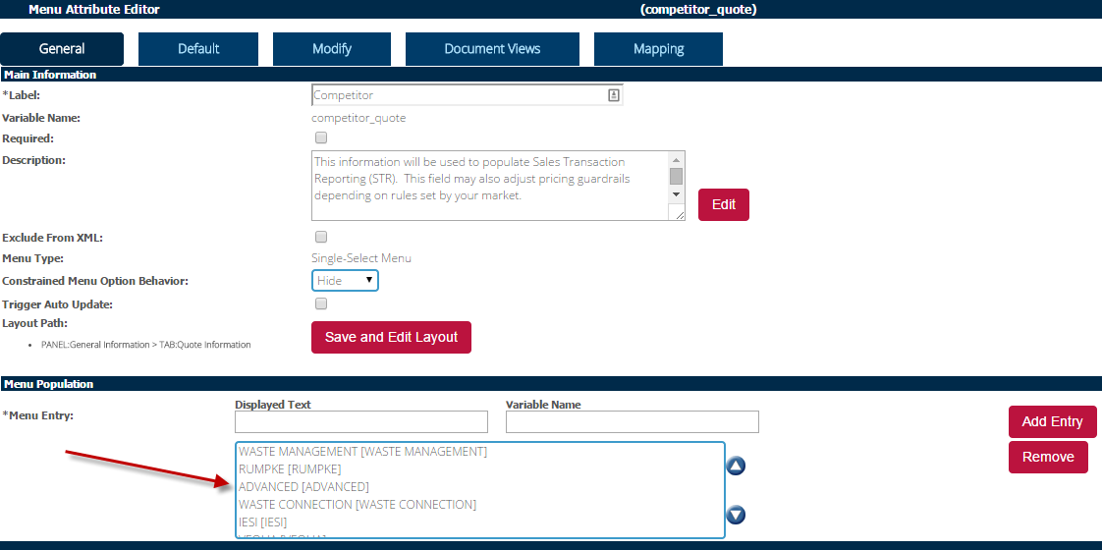

2. Check that the competitor is in the Area Competitors constraint.

Go to Process Definition, Documents, Quote Rules, List and open the constraint entitled ‘Competitors for Area A##’. In the Action (Values to Constrain/Allow) section, click on the Value multi-select list and add any needed competitors.

For example, if you need to add ISEI:

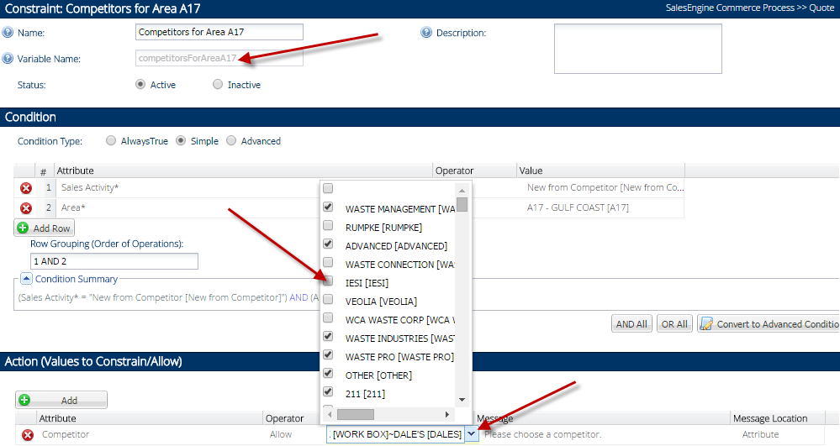

There is an additional step if there is a duplicate competitor name in an Area.  In that case they need to be added to an additional dropdown and another constraint in order to let the user choose the correct competitor code.

# Design

## #87 Competitor List Changes for Gateway Area

## Issue

Here is the list of competitors for Division 4732 in Gateway that need to be included

| **Competitor** | **InfoPro Code** |
| --- | --- |
| BEASLEY | BEA |
| BEASLEY DISPOSAL | BDS |
| BECK TRASH | BEC |
| BOB'S | BOB |
| BOND | BON |
| BRANNUM | BRA |
| BRISK | BRK |
| BULLDOG DISPOSAL | BUL |
| BURRIS | BUR |
| CITY OF DEXTER | COD |
| ED'S | EDS |
| FAMILY TRASH | FAT |
| FREEDOM WASTE | FRE remove- not a competitor in this area |
| FREEDOM WASTE FARMINGTON | FWF |
| HENSON TRASH | HNT |
| IESI | ES |
| INDEPENDENT RECYCLING SERVICE | INR |
| INDIANA WASTE SERVICES | IWA |
| IWI (INDENDENT WASTE) | IWI remove- RSG company now |
| KEN'S DISPOSAL | KEN remove- do not know comp |
| KENNY KASH | KYK |
| KINGERY | KIN remove- out of business |
| LIBERTY | LIB |
| MID-WEST WASTE | MID remove- RSG company now |
| MILAMS DISPOSAL | MLS |
| MISSOURI PLASTICS | MIP remove- burned |
| NEW/NEW | NEW |
| NICHOLS | NIC remove- out of business |
| OTHER | OTH |
| OZARK | OZR |
| OZARKS FOOTHILLS RECYCLING | OFR remove- no accepting outside volume |
| PETE TANNER | TNR |
| PROGRESSIVE | PRG |
| SHULAR | SHU |
| SI WASTE | SIW SI Waste Container- appropriate name |
| SIDCO | SDC remove- RSG company now |
| SL HAULING | SLH remove- out of business |
| SONNY'S SOLID WASTE | SSQ |
| SOUTHERN DISPOSAL | SOD |
| THOMAS DISPOAL | THO |
| THOMURE | TMR |
| TOWN OF HERNDON | TOH remove- not a comp |
| WASTE MANAGEMENT | WMI |
| WOMAC | WOM WOMICK correct spelling |
| ELDRIDGE | ELD |
| Spurlock | SPU |
| BIG DOG | BDO |
| Strickland | Awaiting code |

**Design**

Add the following competitors to division 4732 and Area A33 constraint:  
  
BEASLEY   
BEASLEY DISPOSAL  
BECK TRASH  
BOB'S  
BOND  
BRANNUM  
BRISK  
BURRIS  
CITY OF DEXTER  
ED'S  
FAMILY TRASH  
FREEDOM WASTE FARMINGTON  
HENSON TRASH  
INDEPENDENT RECYCLING SERVICE  
INDIANA WASTE SERVICES  
KENNY KASH  
LIBERTY  
MILAMS DISPOSAL  
OZARK  
PETE TANNER  
SHULAR  
SI WASTE  
SONNY'S SOLID WASTE  
SOUTHERN DISPOSAL  
THOMAS DISPOAL  
THOMURE  
WOMAC  
ELDRIDGE  
NICHOLS  
SPURLOCK  
STRICKLAND

## #229 Add Competitor Waste Connection to Area 33

## Issue/Design

Please add the competitor Waste Connection to A33 using the process outline in section 2.

## #236 Missing Competitors for Division 4097

**Issue/Design**

Add the following competitors to division 4097

FRADES DISPOSAL  
ABC DISPOSAL NEW BEDFORD  
WASTE HAULERS  
PATRIOT-PAWTUCKET, RI  
R J SOUTO  
BIG DOG  
MEGA DISPOSAL  
CAVOSSA  
NAUSET DISPOSAL  
MCNAMARA & SONS  
WASTE TECH

## #250 Add Competitor AREA DISPOSAL to Area 33

**Issue/Design**

Area Disposal is in the Area_Competitor list. Please add AREA DISPOSAL to the list of competitors for A33.

## #289 Competitor list update for Division 4323

**Issue/Design**

The competitor list below needs to be updated for Div 4223 (Cleveland, BU153, OH/W PA Area). In the last two columns, “yes” denotes that the competitor is already showing up in the list. “No” means it is not showing up and needs to be added.

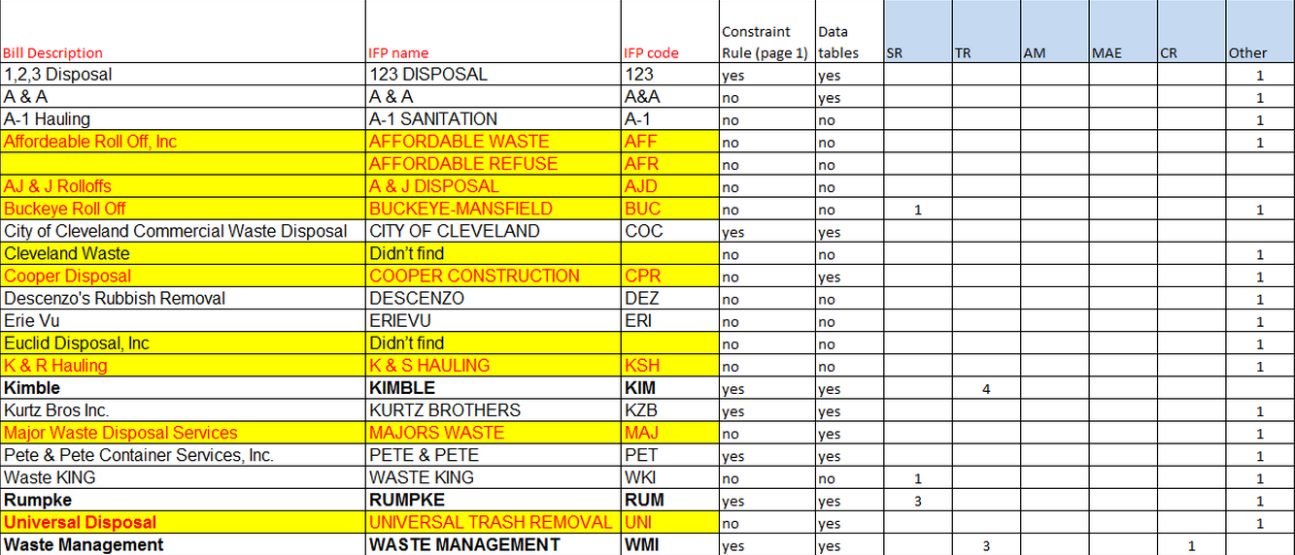

## #296 Add Competitors to Area 33

**Issue/Design**

The following competitors are not listed on the first quote page:  
Burris, Milam's Disposal, Quivey, SL Hauling, SI Waste, Spurlock.

## #377 Area A31 Missing Rays in Competitor List

**Issue/Design**

Please add Rays to the competitor lists (constraint and menu item) for Area A31. RAY is competitor code.

## #371 Add Faherty (FAH) to Area 36

**Issue/Design**

Please add Faherty to the competitor lists (constraint and menu item) for Area A36. FAH is competitor code.

## #370 Area A36 Missing Competitors for BU 327

**Issue/Design**

Please add the following competitor lists to Capture (constraint and menu item) for Area A36.

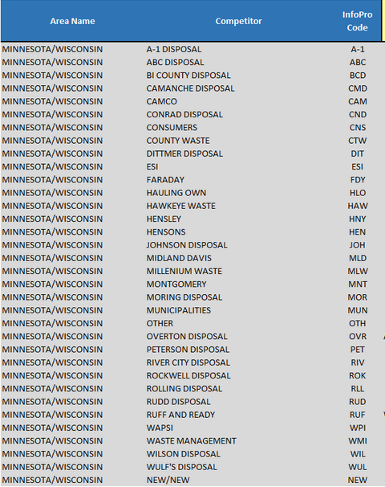

## #351 Missing Trash Kans LLC from the list of new compititors for A31

**Issue/Design**

Add Trash Kans LLC (code – TKL) to the menu items and constraint for A31 within Capture.

## #389 Remove Competitor FSI Deisposal

**Issue/Design**

Remove competitor FSI Disposal from competitorsForAreaA34 (Constraint and Menu Item)

# InfoPro Interface

No new variable should be needed and no existing variables should be repurposed.

# Report Changes

NA

# Appendix